SHORT BIO WITH REVIEWS
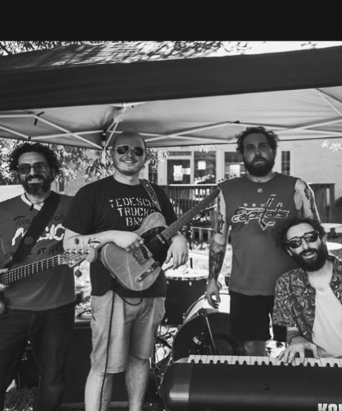
Brother Rust was formed in 2022 in Denver, Colorado as a songwriting project, evolving into a live act in 2024 after Charlie Spence’ move to Maryland.
Spence brings extensive live performance experience. For nearly five years, Spence held residencies in downtown Denver, with performances at AXS and Live Nation venues across Colorado. His music has been featured on 93.3 KTCL (Denver) and online radio shows. Today, the band brings a repertoire of up to four hours of original and cover music.
“Brother Rust’s sound draws closely to Soul, Country, and Rock n’ Roll traditions, blending thoughtful, story-driven songwriting with groove-centered arrangements that feature electric and acoustic guitars, piano, organ, bass, and percussion. Their music reflects the expansive influence of the Rocky Mountain scene and the collaborative energy of the DMV/Chesapeake region.” (yourtownmusic.com)
🔗 Brother Rust Media Clips
“Coverage of Brother Rust’s live performances in Frederick event listings, including shared bills with regional acts at venues such as Café Nola and The Sandbox Brewhouse, underscoring their active presence on the local scene.” (frederickfrequency.com)

MUSIC
Featured Track: “Wheelin’ & Dealin’” — flagship single from High & Lonesome Life (2025)
Songs of note: “Ties That Bind,” “Drinking with Ghosts,” “Come Back Home”
Streaming available on all major platforms. Spotify | Apple Music | iHeart Radio

PRESS
The Frederick News-Post:
“...opened with a slow, blues-leaning number that immediately showcased their chemistry. Spence’s smooth, soulful tone paired seamlessly with Rowel’s bright harmonies, creating a sound that felt both timeless and grounded.” -S.D. Price – (Frederick News Post)
Your Town Music:
“Brother Rust … this easy-going, roots rock ballad is filled with great instrumental performances and an absolute earworm hook.” — Your Town Music on “Wheelin’ & Dealin’”. (yourtownmusic.com)
Frederick Frequency:
“Their single “Wheelin’ & Dealin’” (2025) highlights the band’s sonic range: warm slide guitar, melodic piano, tight bass, and spirited percussion anchored by reflective lyrics about navigating life’s trade-offs. Brother Rust has been featured in Your Town Music, Frederick Frequency, and the Frederick News-Post, emphasizing their contribution to the original music scene and growing live presence in Maryland and beyond.” (frederickfrequency.com)

RECENT LIVE PERFORMANCE HISTORY (SELECTED)
Thorpewood Holiday Open House | Thurmont, MD | Dec 10, 2024
Café Nola | Frederick, MD [With Matthew Scott & The Houseplants] | Nov 22, 2025
The Sandbox Brewhouse | Frederick, MD [With James Bontempo & Truth Tables and Viennetta] | Nov 8, 2025
Halloween Private Event | Shepherdstown, WV [With Ginada Piñata] | Oct 31, 2025
Weekly Residency at Appaloosa Grill | Denver, CO | 2018–2023
Headlined and supported across AXS + Live Nation Promoted Venues | Denver, CO | 2017–2024
For more information about past performances or upcoming events, contact management.

